20.36: For those with a knowledge of elementary probability, all of the results for this exercise are obtained from

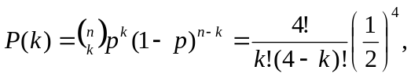

where P(k) is the probability of obtaining k heads, 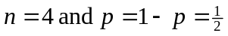 for a fair coin. This is of course consistent with Fig. (20.18).

- 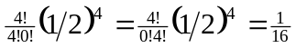 for all heads or all tails. b) 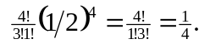
c) 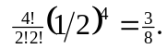 d) 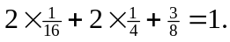 The number of heads must be one of 0, 1, 2, 3 or 4, and there must be unit probability of one and only one of these possibilities.

